Gradient Descent
A Comprehensive Guide to Optimization Algorithms
An in-depth exploration of gradient descent algorithms, mathematical foundations, and practical applications in machine learning.
Autor: Maru
February 2026

Introduction to Gradient Descent
Gradient descent is a fundamental optimization algorithm used extensively in machine learning and deep learning. It is an iterative method that aims to find the minimum of a cost function by taking steps proportional to the negative of the gradient at the current point. The algorithm is simple yet powerful, serving as the backbone for training neural networks and other machine learning models.The core idea behind gradient descent is intuitive: imagine standing on a hillside and wanting to reach the valley (minimum) as quickly as possible. The steepest descent direction is indicated by the negative gradient, and by repeatedly taking steps in this direction, we eventually reach the bottom of the valley.

Mathematical Foundations

The Gradient and Derivative
The gradient is a vector of partial derivatives that points in the direction of the steepest increase of a function. For a function f(x), the gradient ∇f(x) indicates how the function changes with respect to each variable. The derivative, a special case of the gradient for single-variable functions, measures the rate of change.
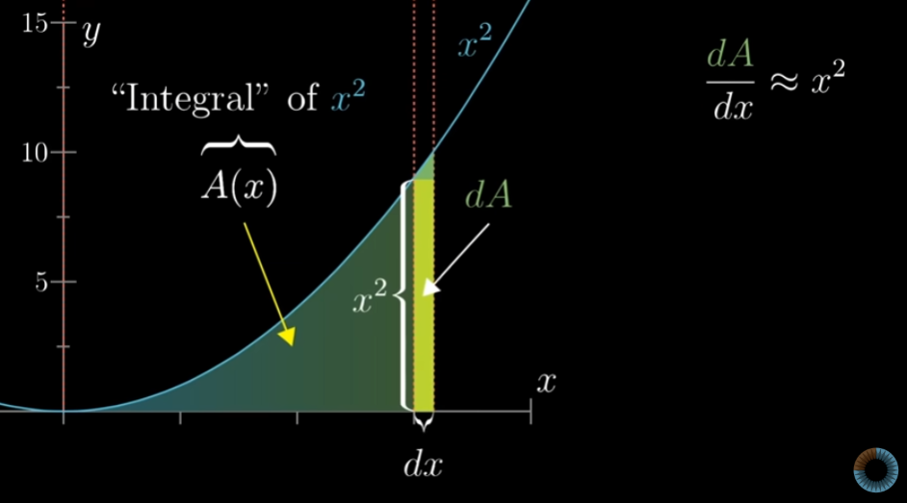
Figure 1: Visual representation of derivatives and gradient descent direction on a cost function.
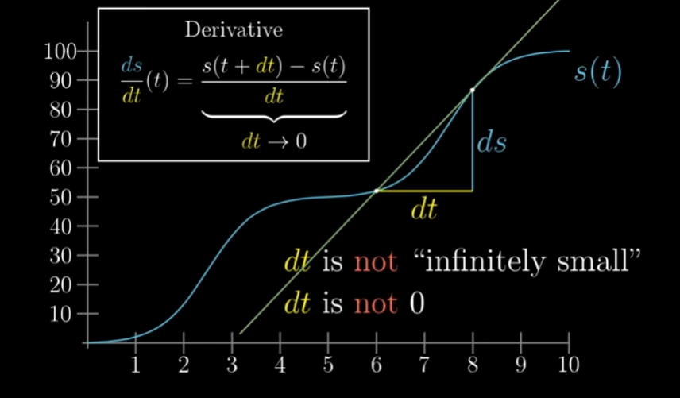
Figure 2: Derivative concept showing the rate of change of a function at a point.
$\frac{ds}{dt}(t)=\lim_{dt→0}\frac{s(t+dt)−s(t)}{dt}$
Equation 1: Definition of the derivative as the limit of the rate of change.

The Gradient Descent Update Rule
The fundamental update rule for gradient descent is expressed as follows. At each iteration, parameters are updated by moving in the direction opposite to the gradient, scaled by a learning rate α. This learning rate controls the step size and is crucial for convergence.
$θ_{t+1}=θ_{t}−α∇J(θ_{t})$
Equation 2: Gradient descent update rule where θ represents parameters, α is the learning rate, and ∇J is the gradient of the cost function.
In this equation, θ represents the parameters being optimized, J(θ) is the cost function, and α is the learning rate—a hyperparameter that determines how large each step should be. A learning rate that is too large may cause the algorithm to overshoot the minimum, while a learning rate that is too small will result in slow convergence.
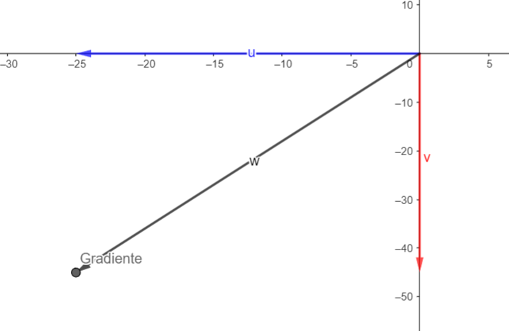
Figure 3: Visualization of the gradient vector and its direction in parameter space.

Types of Gradient Descent

Batch Gradient Descent
Batch Gradient Descent computes the gradient using the entire training dataset before updating the parameters. This approach provides a stable and accurate estimate of the gradient but can be computationally expensive for large datasets. The algorithm is guaranteed to converge to a local minimum for convex functions.
$J(θ)=\frac{1}{m}\sum_{i=1}^{m}{L(h_{θ}(x^{(i)}),y^{(i)})}$
Equation 3: Cost function for batch gradient descent, where m is the number of training samples.

Stochastic Gradient Descent (SGD)
Stochastic Gradient Descent updates parameters using the gradient computed from a single training example at each iteration. This approach is much faster than batch gradient descent and can escape local minima more easily due to its noisy updates. However, the convergence path is more erratic.
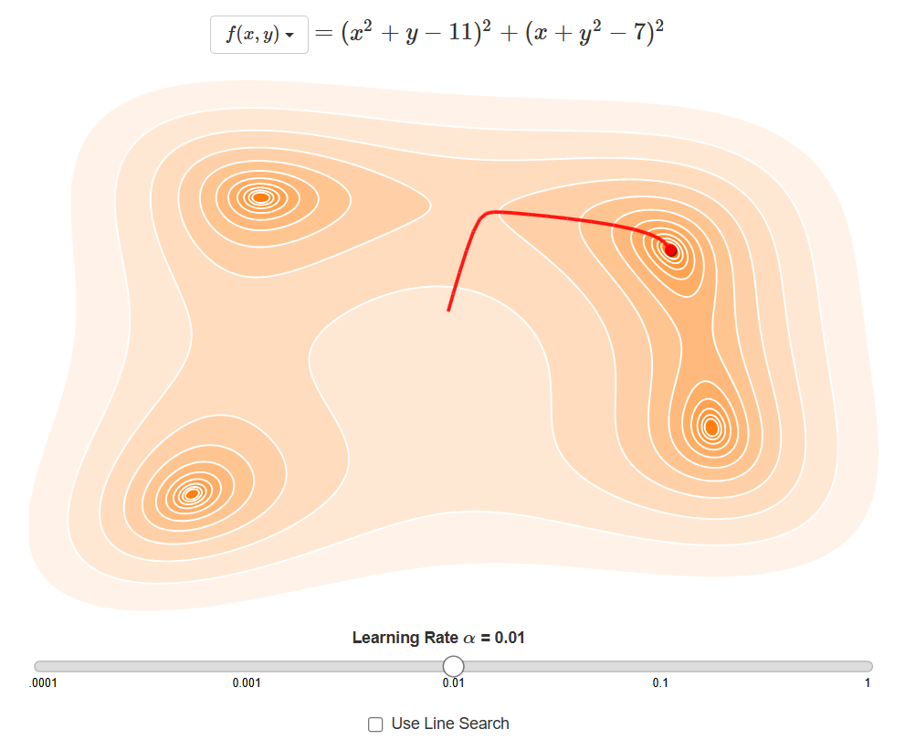
Figure 4: Comparison of batch gradient descent (left) and stochastic gradient descent (right) convergence paths.
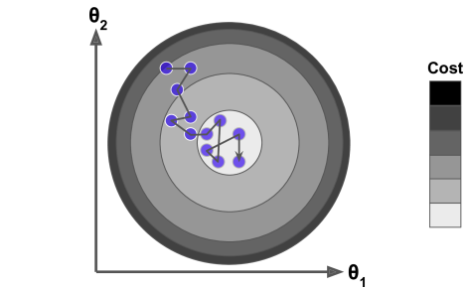
Figure 5: Stochastic gradient descent showing noisy but faster convergence.

Mini-Batch Gradient Descent
Mini-Batch Gradient Descent strikes a balance between batch and stochastic approaches by computing the gradient on small subsets (mini-batches) of the training data. This method combines the stability of batch gradient descent with the computational efficiency of stochastic gradient descent, making it the most popular choice in practice.
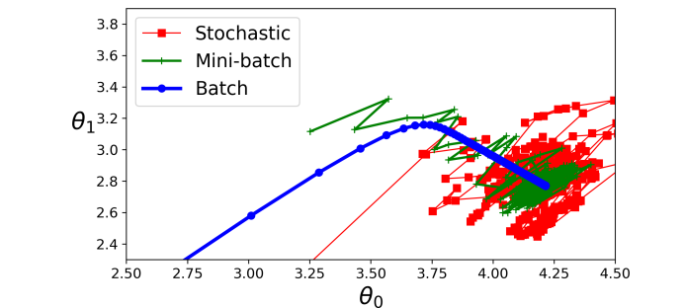
Figure 6: Comparison of convergence paths for batch, mini-batch, and stochastic gradient descent.

Comparison of Gradient Descent Variants
Table 1: Comparison of different gradient descent variants.
Variant | Computation | Speed | Stability | Memory
Batch | Entire dataset | Slow | Very stable | High
Stochastic | Single sample | Fast | Unstable | Low
Mini-Batch | Small subset | Moderate | Stable | Moderate

Learning Rate and Convergence
The learning rate α is one of the most important hyperparameters in gradient descent. It controls the size of the steps taken toward the minimum. The choice of learning rate significantly affects the convergence behavior and final performance of the algorithm.
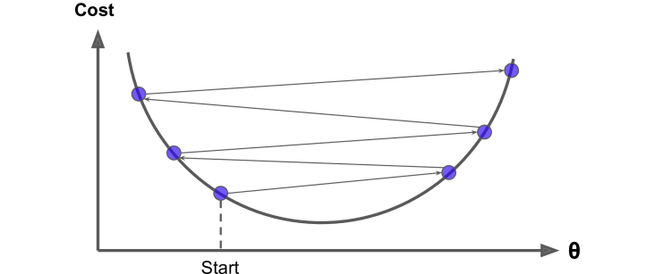
Figure 7: Effect of learning rate on convergence behavior and optimization path.

Challenges and Pitfalls
Gradient descent faces several challenges in practice. Local minima occur when the algorithm converges to a point that is not the global minimum. Plateaus are regions where the gradient is very small, causing slow convergence. Saddle points are critical points where the gradient is zero but the point is neither a minimum nor a maximum.
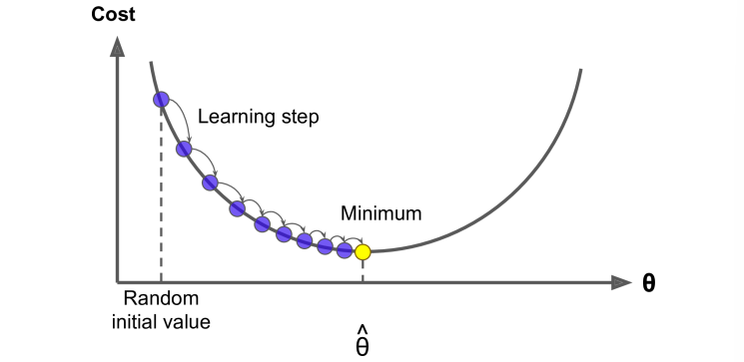
Figure 8: Visualization of local minima, plateaus, and saddle points in optimization landscapes.
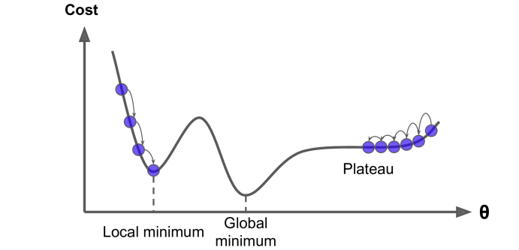
Figure 9: Common pitfalls in gradient descent optimization.

Multivariable Functions and Partial Derivatives
When optimizing functions of multiple variables, we use partial derivatives to compute the gradient. The gradient is a vector containing all partial derivatives, indicating the direction of steepest ascent in the multidimensional space.
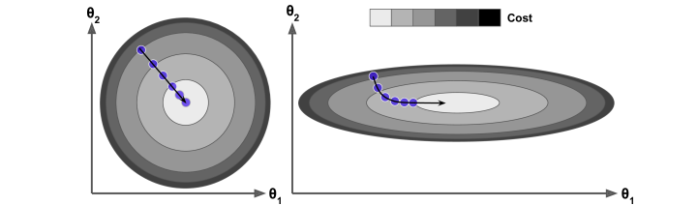
Figure 10: Gradient descent in two-dimensional parameter space showing convergence to the minimum.
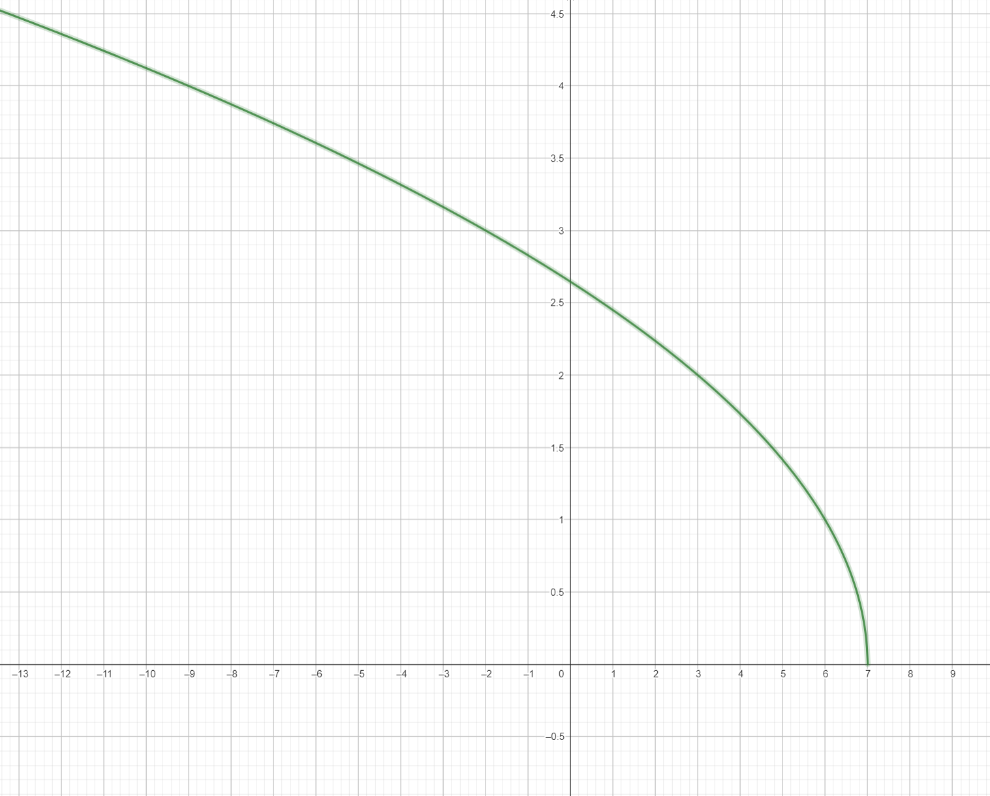
Figure 11: Three-dimensional visualization of a multivariable function and its domain.
$∇f(x,y)=\left(\frac{∂f}{∂x},\frac{∂f}{∂y}\right)$
Equation 4: Gradient vector for a two-variable function.

Calculus Concepts Supporting Gradient Descent
Understanding gradient descent requires knowledge of several calculus concepts. Integration represents the accumulation of quantities, while derivatives represent rates of change. The first derivative test helps identify local extrema by examining where the derivative equals zero.
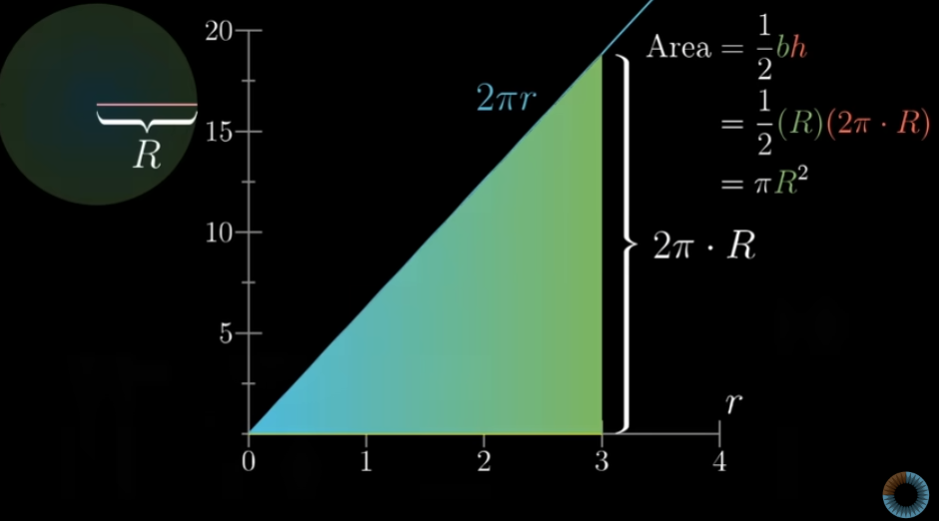
Figure 12: Integration concept showing area under a curve.
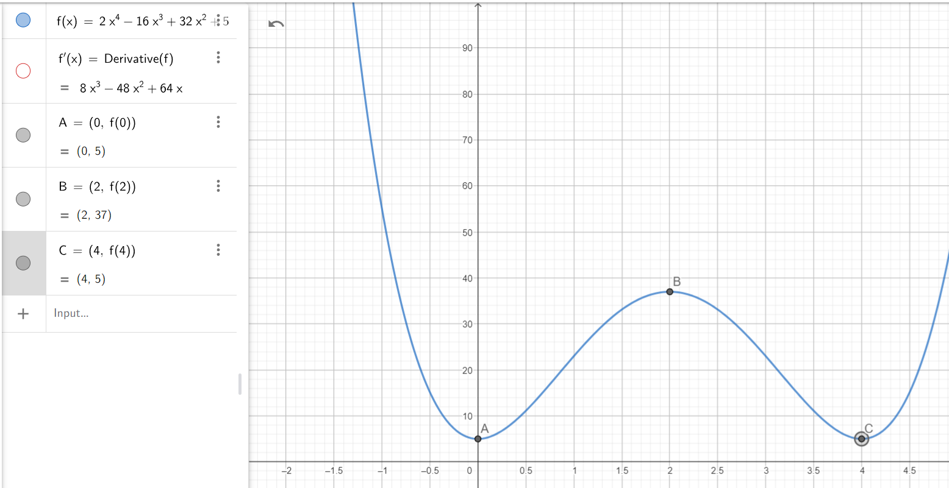
Figure 13: First derivative test for identifying critical points and extrema.
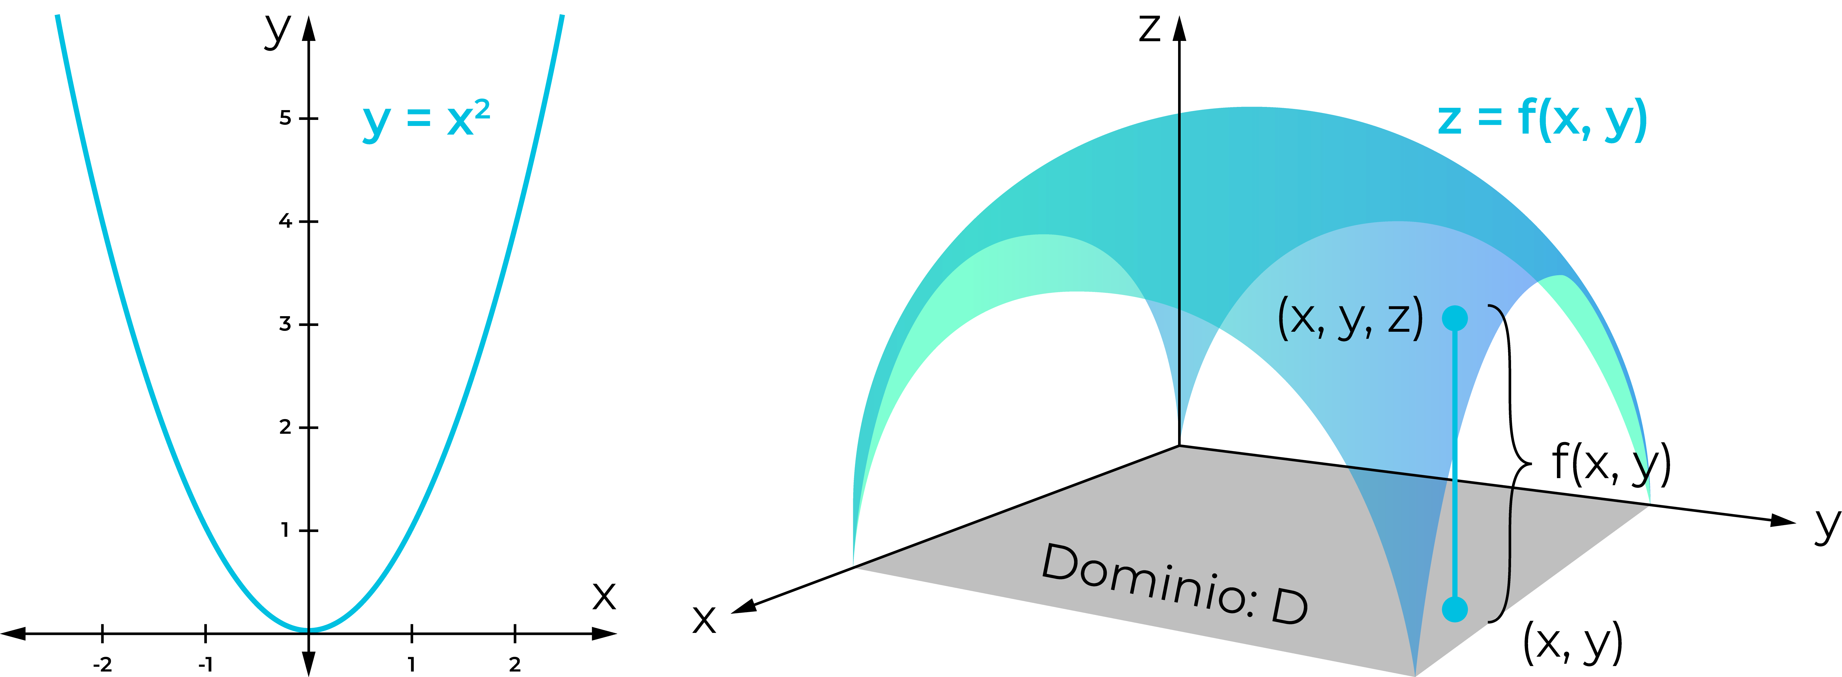
Figure 14: Comprehensive visualization of functions, derivatives, and critical points.

Practical Implementation Considerations
When implementing gradient descent in practice, several factors must be considered. Feature scaling ensures that all features contribute equally to the gradient computation. Convergence criteria determine when to stop the algorithm. Hyperparameter tuning of the learning rate and batch size significantly impacts performance.
Table 2: Practical considerations and solutions in gradient descent implementation.
Consideration | Impact | Solution
Learning rate too high | Divergence or oscillation | Reduce learning rate or use adaptive methods
Learning rate too low | Slow convergence | Increase learning rate or use adaptive methods
Unscaled features | Biased gradients | Normalize or standardize features
Large batch size | Slow updates | Use mini-batches or adaptive learning rates
Small batch size | Noisy gradients | Increase batch size or use regularization

Advanced Optimization Algorithms
Beyond basic gradient descent, several advanced optimization algorithms have been developed to improve convergence speed and stability. Momentum accumulates gradients over time to accelerate convergence. Adaptive learning rate methods like Adam and RMSprop adjust the learning rate for each parameter individually based on historical gradients.
$θ_{t+1}=θ_{t}−α\frac{m_{t}}{\sqrt{v_{t}}+ϵ}$
Equation 5: Adam optimizer update rule using first and second moment estimates.

Conclusion
Gradient descent is a cornerstone algorithm in machine learning and optimization. Understanding its mathematical foundations, variants, and practical considerations is essential for effectively training machine learning models. While basic gradient descent is simple and intuitive, modern applications often benefit from advanced variants and adaptive learning rate methods that address convergence challenges and improve training efficiency.The choice between batch, stochastic, and mini-batch gradient descent depends on the specific problem, dataset size, and computational resources available. By carefully tuning the learning rate and considering the optimization landscape, practitioners can leverage gradient descent to successfully train powerful machine learning models.

